|  |  |
| --- | --- |
| **Star 1 Elements Award Sheet** | |
| **Host Club:** |  |
| **Skater Name:** |  |
| **Home Club:** |  |
| **Date:** |  |

**INSERT**

**CLUB**

**LOGO**

**HERE**

**INSERT**

**CLUB**

**LOGO**

**HERE**

| OVERALL AWARD |
| --- |
|  |

|  |  |
| --- | --- |
| **ELEMENT ASSESSMENT** | |
| **WALTZ JUMP** |  |
| **SALCHOW JUMP** |  |
| **UPRIGHT SPIN (FWD)** |  |
| **FORWARD SPIRAL SEQUENCE** |  |

**Gold:** At least two elements assessed at Gold. No element assessed below Silver.

**Silver:** At least two elements assessed at the Silver level or higher. No element assessed below Bronze.

**Bronze:** At least two elements assessed at the Bronze or higher level.

|  |  |
| --- | --- |
| **ELEMENT ASSESSMENT** | |
| **WALTZ + TOE LOOP COMBO JUMP** |  |
| **LOOP JUMP** |  |
| **BACKWARD UPRIGHT SPIN** |  |
| **FORWARD SPIRAL SEQUENCE** |  |

|  |  |
| --- | --- |
| **Star 2 Elements Award Sheet** | |
| **Host Club:** |  |
| **Skater Name:** |  |
| **Home Club:** |  |
| **Date:** |  |

| OVERALL AWARD |
| --- |
|  |

**INSERT**

**CLUB**

**LOGO**

**HERE**

**INSERT**

**CLUB**

**LOGO**

**HERE**

**Gold:** At least two elements assessed at Gold. No element assessed below Silver.

**Silver:** At least two elements assessed at the Silver level or higher. No element assessed below Bronze.

**Bronze:** At least two elements assessed at the Bronze or higher level.

|  |  |
| --- | --- |
| **Star 3 Elements Award Sheet** | |
| **Host Club:** |  |
| **Skater Name:** |  |
| **Home Club:** |  |
| **Date:** |  |

| OVERALL AWARD |
| --- |
|  |

|  |  |
| --- | --- |
| **ELEMENT ASSESSMENT** | |
| **FLIP JUMP** |  |
| **LOOP+ LOOP COMBO JUMP** |  |
| **COMBO SPIN** |  |
| **FORWARD SPIRAL SEQUENCE** |  |

**INSERT**

**CLUB**

**LOGO**

**HERE**

**INSERT**

**CLUB**

**LOGO**

**HERE**

**Gold:** At least two elements assessed at Gold. No element assessed below Silver.

**Silver:** At least two elements assessed at the Silver level or higher. No element assessed below Bronze.

**Bronze:** At least two elements assessed at the Bronze or higher level.

|  |  |
| --- | --- |
| **ELEMENT ASSESSMENT** | |
| **WALTZ JUMP** |  |
| **SALCHOW JUMP** |  |
| **UPRIGHT SPIN (FWD)** |  |
| **FORWARD SPIRAL SEQUENCE** |  |

|  |  |
| --- | --- |
| **Star 1 Team Elements Award Sheet** | |
| **Host Club:** |  |
| **Skater Name:** |  |
| **Home Club:** |  |
| **Date:** |  |

| OVERALL AWARD |
| --- |
|  |

**INSERT**

**CLUB**

**LOGO**

**HERE**

**INSERT**

**CLUB**

**LOGO**

**HERE**

**Gold:** At least two elements assessed at Gold. No element assessed below Silver.

**Silver:** At least two elements assessed at the Silver level or higher. No element assessed below Bronze.

**Bronze:** At least two elements assessed at the Bronze or higher level.

|  |  |
| --- | --- |
| **Star 2 Team Elements Award Sheet** | |
| **Host Club:** |  |
| **Skater Name:** |  |
| **Home Club:** |  |
| **Date:** |  |

| OVERALL AWARD |
| --- |
|  |

**INSERT**

**CLUB**

**LOGO**

**HERE**

**INSERT**

**CLUB**

**LOGO**

**HERE**

**Gold:** At least two elements assessed at Gold. No element assessed below Silver.

**Silver:** At least two elements assessed at the Silver level or higher. No element assessed below Bronze.

**Bronze:** At least two elements assessed at the Bronze or higher level.

|  |  |
| --- | --- |
| **ELEMENT ASSESSMENT** | |
| **LOOP JUMP** |  |
| **WALTZ + TOE LOOP COMBO JUMP** |  |
| **BACKWARD UPRIGHT SPIN** |  |
| **FORWARD SPIRAL SEQUENCE** |  |

|  |  |
| --- | --- |
| **Star 3 Team Elements Award Sheet** | |
| **Host Club:** |  |
| **Skater Name:** |  |
| **Home Club:** |  |
| **Date:** |  |

| OVERALL AWARD |
| --- |
|  |

**INSERT**

**CLUB**

**LOGO**

**HERE**

**INSERT**

**CLUB**

**LOGO**

**HERE**

**Gold:** At least two elements assessed at Gold. No element assessed below Silver.

**Silver:** At least two elements assessed at the Silver level or higher. No element assessed below Bronze.

**Bronze:** At least two elements assessed at the Bronze or higher level.

|  |  |
| --- | --- |
| **ELEMENT ASSESSMENT** | |
| **FLIP JUMP** |  |
| **LOOP+ LOOP COMBO JUMP** |  |
| **COMBO SPIN** |  |
| **SPIRAL SEQUENCE** |  |

| OVERALL AWARD |
| --- |
|  |

| STROKING | |
| --- | --- |
| **STROKING EXERCISE** |  |
| **JUMPS** | |
| **WALTZ JUMP** |  |
| **SALCHOW JUMP** |  |
| **TOE LOOP JUMP** |  |
| **SPINS** | |
| **FORWARD UPRIGHT SPIN** |  |
| **BACKWARD UPRIGHT SPIN** |  |
| **OTHER** | |
| **SPIRAL EXERCISE** |  |
| **CREATIVE EXPRESSION ROUTINE** |  |

|  |  |
| --- | --- |
| **Star 1 Freeskate Award Sheet** | |
| **Host Club:** |  |
| **Skater Name:** |  |
| **Home Club:** |  |
| **Date:** |  |

**INSERT**

**CLUB**

**LOGO**

**HERE**

**INSERT**

**CLUB**

**LOGO**

**HERE**

**GOLD:** At least four elements at the Gold level.

**SILVER:** At least four elements at the Silver or Gold level.

**BRONZE:** At least four elements at the Bronze or higher level.

The Creative Expression Routine must be completed to achieve any performance award at the BRONZE, SILVER or GOLD level.

|  |  |
| --- | --- |
| **Star 2 Freeskate Award Sheet** | |
| **Host Club:** |  |
| **Skater Name:** |  |
| **Home Club:** |  |
| **Date:** |  |

| OVERALL AWARD |
| --- |
|  |

| JUMPS | |
| --- | --- |
| **WALTZ + TOE COMBO JUMP** |  |
| **TOE LOOP JUMP** |  |
| **SALCHOW JUMP** |  |
| **LOOP JUMP** |  |
| **FLIP OR LUTZ JUMP** |  |

| SPINS | |
| --- | --- |
| **BACKWARD UPRIGHT SPIN** |  |
| **SIT SPIN OR CAMEL SPIN** |  |

| OTHER | |
| --- | --- |
| **3 TURN SEQUENCE** |  |
| **FORWARD SPIRAL SEQUENCE** |  |

| PROGRAM COMPONENTS | |
| --- | --- |
| **SKATING SKILLS** |  |
| **PERFORMANCE & EXECUTION** |  |

**INSERT**

**CLUB**

**LOGO**

**HERE**

**INSERT**

**CLUB**

**LOGO**

**HERE**

**GOLD:** At least seven assessments at the Gold level, Skating Skills at least Silver.

**SILVER:** At least seven assessments at the Silver level or higher, Skating Skills at least Bronze.

**BRONZE**: At least seven assessments at the Bronze or higher, Skating Skills at least Bronze.

|  |  |
| --- | --- |
| **Star 3 Freeskate Award Sheet** | |
| **Host Club:** |  |
| **Skater Name:** |  |
| **Home Club:** |  |
| **Date:** |  |

| OVERALL AWARD |
| --- |
|  |

**INSERT**

**CLUB**

**LOGO**

**HERE**

**INSERT**

**CLUB**

**LOGO**

**HERE**

**GOLD:** At least seven assessments at the Gold level, Skating Skills & Performance at least Silver.

**SILVER:** At least seven assessments at the Silver level or higher, Skating Skills & Performance at least Bronze.

**BRONZE:** At least seven assessments at the Bronze or higher, Skating Skills & Performance at least Bronze.

| JUMPS | |
| --- | --- |
| **WALTZ or AXEL (Mandatory)** |  |
| **LOOP + LOOP (Mandatory)** |  |
| **JUMP 3** |  |
| **JUMP 4** |  |
| **JUMP 5** |  |

| SPINS | |
| --- | --- |
| **BACKWARD UPRIGHT SPIN** |  |
| **COMBO SPIN** |  |

| OTHER | |
| --- | --- |
| **FORWARD SPIRAL SEQUENCE** |  |

| PROGRAM COMPONENTS | |
| --- | --- |
| **SKATING SKILLS** |  |
| **PERFORMANCE & EXECUTION** |  |
| **INTERPRETATION** |  |

|  |  |
| --- | --- |
| **Level 1 Creative Expression Award Sheet** | |
| **Host Club:** |  |
| **Skater Name:** |  |
| **Home Club:** |  |
| **Date:** |  |

| OVERALL AWARD |
| --- |
|  |

**INSERT**

**CLUB**

**LOGO**

**HERE**

**INSERT**

**CLUB**

**LOGO**

**HERE**

| PROGRAM COMPONENTS | |
| --- | --- |
| **SKATING SKILLS** |  |
| **PERFORMANCE & EXECUTION** |  |
| **INTERPRETATION** |  |

**GOLD:** All three assessments at Gold Level

**SILVER:** At least two assessments at the Silver level or higher, No assessments below Bronze

**BRONZE:** At least two assessments at the Bronze or higher

|  |  |
| --- | --- |
| **Level 2 Creative Expression Award Sheet** | |
| **Host Club:** |  |
| **Skater Name:** |  |
| **Home Club:** |  |
| **Date:** |  |

| OVERALL AWARD |
| --- |
|  |

**INSERT**

**CLUB**

**LOGO**

**HERE**

**INSERT**

**CLUB**

**LOGO**

**HERE**

**GOLD:** All three assessments at Gold Level

**SILVER:** At least two assessments at the Silver level or higher, No assessments below Bronze

**BRONZE:** At least two assessments at the Bronze or higher

| PROGRAM COMPONENTS | |
| --- | --- |
| **SKATING SKILLS** |  |
| **PERFORMANCE & EXECUTION** |  |
| **INTERPRETATION** |  |

|  |  |
| --- | --- |
| **Pre-Introductory Interpretive Award Sheet** | |
| **Host Club:** |  |
| **Skater Name:** |  |
| **Home Club:** |  |
| **Date:** |  |

| OVERALL AWARD |
| --- |
|  |

**INSERT**

**CLUB**

**LOGO**

**HERE**

**INSERT**

**CLUB**

**LOGO**

**HERE**

**GOLD:** All three assessments at Gold Level

**SILVER:** At least two assessments at the Silver level or higher, No assessments below Bronze

**BRONZE:** At least two assessments at the Bronze or higher

| PROGRAM COMPONENTS | |
| --- | --- |
| **SKATING SKILLS** |  |
| **PERFORMANCE & EXECUTION** |  |
| **INTERPRETATION** |  |

|  |  |
| --- | --- |
| **Pre-Introductory Interpretive Couples Award Sheet** | |
| **Host Club:** |  |
| **Skater Name:** |  |
| **Home Club:** |  |
| **Date:** |  |

| OVERALL AWARD |
| --- |
|  |

**INSERT**

**CLUB**

**LOGO**

**HERE**

| PROGRAM COMPONENTS | |
| --- | --- |
| **SKATING SKILLS** |  |
| **PERFORMANCE & EXECUTION** |  |
| **INTERPRETATION** |  |

**GOLD:** All three assessments at Gold Level

**SILVER:** At least two assessments at the Silver level or higher, No assessments below Bronze

**BRONZE:** At least two assessments at the Bronze or higher

**INSERT**

**CLUB**

**LOGO**

**HERE**

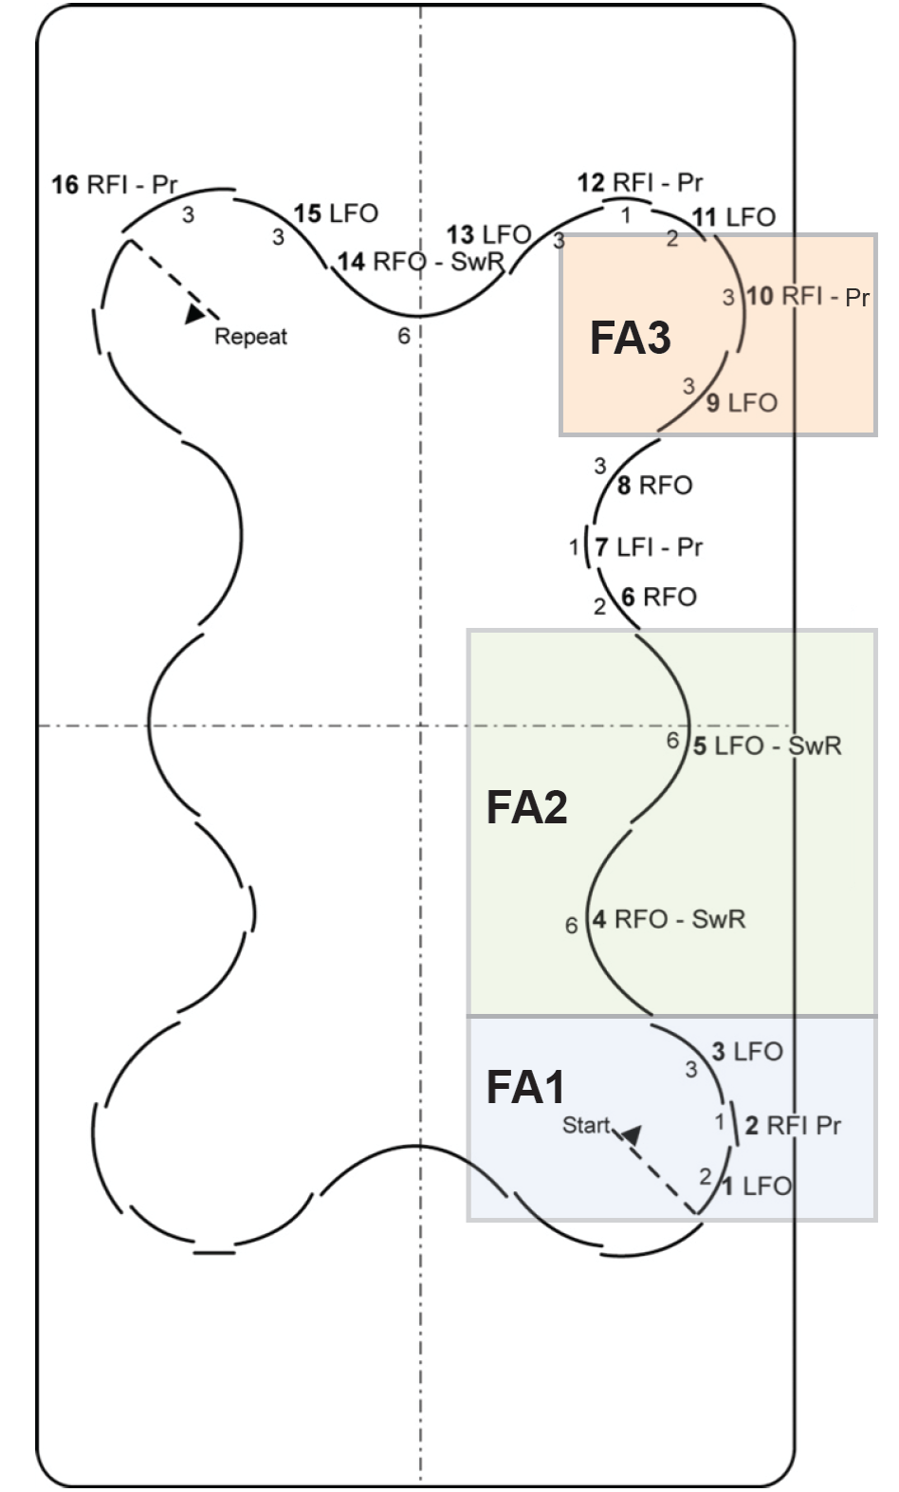

**INSERT**

**CLUB**

**LOGO**

**HERE**

|  |  |
| --- | --- |
| STAR ⅔ PATTERN DANCE SOLO  **DUTCH WALTZ** | |
| **Host Club:** |  |
| **Skater Name:** |  |
| **Home Club:** |  |
| **Date:** |  |

| OVERALL AWARD |
| --- |
|  |

| CRITERIA | |
| --- | --- |
| **TIMING** |  |
| **CARRIAGE** |  |
| **TECHNIQUE** |  |

**Gold:** 2 assessments at Gold, Timing at least Silver. 2 of 3 Focus Areas must be successful.

**Silver:** 2 assessments at Silver or better, Timing at least Silver. 2 of 3 Focus Areas must be successful.

**Bronze:** 2 assessments at Bronze or better, Timing at Bronze.

**\*Automatic Bronze overall rating if 2 or more Focus Areas are unsuccessful**

| FOCUS AREA | | |
| --- | --- | --- |
| ELEMENT | SUCCESSFUL | UNSUCCESSFUL |
| **FOCUS AREA #1 (STEPS 1, 2, 3)** |  |  |
| **FOCUS AREA #2 (STEPS 4, 5)** |  |  |
| **FOCUS AREA #3 (STEPS 9, 10)** |  |  |
| **\*MINIMUM 2 FOCUS AREAS RATED SUCCESSFUL** | | **YES NO** |

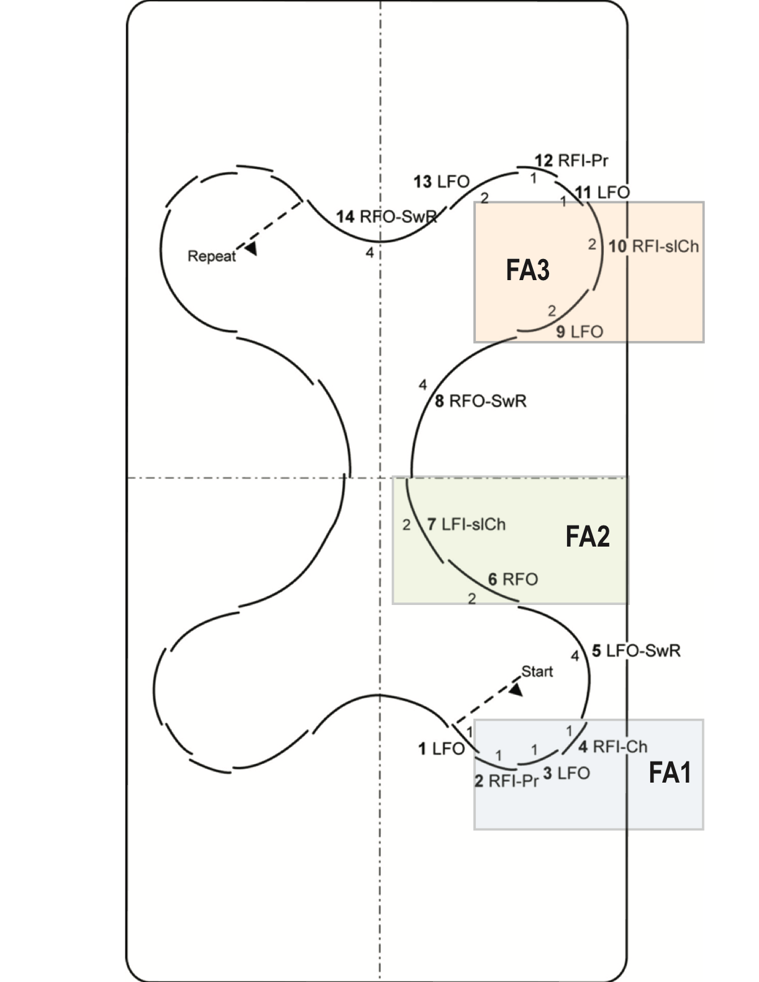

**INSERT**

**CLUB**

**LOGO**

**HERE**

|  |  |
| --- | --- |
| STAR ⅔ PATTERN DANCE SOLO  **CANASTA TANGO** | |
| **Host Club:** |  |
| **Skater Name:** |  |
| **Home Club:** |  |
| **Date:** |  |

| OVERALL AWARD |
| --- |
|  |

| CRITERIA | |
| --- | --- |
| **TIMING** |  |
| **CARRIAGE** |  |
| **TECHNIQUE** |  |

**Gold:** 2 assessments at Gold, Timing at least Silver. 2 of 3 Focus Areas must be successful.

**Silver:** 2 assessments at Silver or better, Timing at least Silver. 2 of 3 Focus Areas must be successful.

**Bronze:** 2 assessments at Bronze or better, Timing at Bronze.

**\*Automatic Bronze overall rating if 2 or more Focus Areas are unsuccessful**

| FOCUS AREA | | |
| --- | --- | --- |
| ELEMENT | SUCCESSFUL | UNSUCCESSFUL |
| **FOCUS AREA #1 (STEPS 2, 3, 4)** |  |  |
| **FOCUS AREA #2 (STEPS 6, 7)** |  |  |
| **FOCUS AREA #3 (STEPS 9, 10)** |  |  |
| **\*MINIMUM 2 FOCUS AREAS RATED SUCCESSFUL** | | **YES NO** |

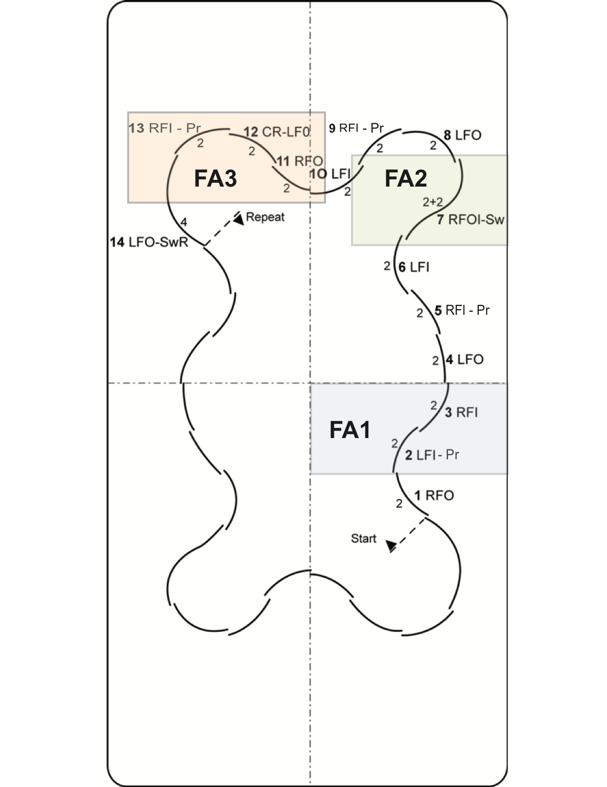

**INSERT**

**CLUB**

**LOGO**

**HERE**

|  |  |
| --- | --- |
| STAR ⅔ PATTERN DANCE SOLO  **BABY BLUES** | |
| **Host Club:** |  |
| **Skater Name:** |  |
| **Home Club:** |  |
| **Date:** |  |

| OVERALL AWARD |
| --- |
|  |

| CRITERIA | |
| --- | --- |
| **TIMING** |  |
| **CARRIAGE** |  |
| **TECHNIQUE** |  |

**Gold:** 2 assessments at Gold, Timing at least Silver. 2 of 3 Focus Areas must be successful.

**Silver:** 2 assessments at Silver or better, Timing at least Silver. 2 of 3 Focus Areas must be successful.

**Bronze:** 2assessments at Bronze or better, Timing at Bronze.

**\*Automatic Bronze overall rating if 2 or more Focus Areas are unsuccessful**

| FOCUS AREA | | |
| --- | --- | --- |
| ELEMENT | SUCCESSFUL | UNSUCCESSFUL |
| **FOCUS AREA #1 (STEPS 2, 3)** |  |  |
| **FOCUS AREA #2 (STEPS 7)** |  |  |
| **FOCUS AREA #3 (STEPS 11, 12, 13)** |  |  |
| **\*MINIMUM 2 FOCUS AREAS RATED SUCCESSFUL** | | **YES NO** |



**INSERT**

**CLUB**

**LOGO**

**HERE**

|  |  |
| --- | --- |
| STAR ⅔ PATTERN DANCE COUPLES  **CANASTA TANGO** | |
| **Host Club:** |  |
| **Skater Name:** |  |
| **Home Club:** |  |
| **Date:** |  |

| OVERALL AWARD |
| --- |
|  |

| CRITERIA | |
| --- | --- |
| **TIMING** |  |
| **CARRIAGE** |  |
| **TECHNIQUE** |  |

**Gold:** 2 assessments at Gold, Timing at least Silver. 2 of 3 Focus Areas must be successful.

**Silver:** 2 assessments at Silver or better, Timing at least Silver. 2 of 3 Focus Areas must be successful.

**Bronze:** 2 assessments at Bronze or better, Timing at Bronze.

**\*Automatic Bronze overall rating if 2 or more Focus Areas are unsuccessful**

| FOCUS AREA | | |
| --- | --- | --- |
| ELEMENT | SUCCESSFUL | UNSUCCESSFUL |
| **FOCUS AREA #1 (STEPS 2, 3, 4)** |  |  |
| **FOCUS AREA #2 (STEPS 6, 7)** |  |  |
| **FOCUS AREA #3 (STEPS 9, 10)** |  |  |
| **\*MINIMUM 2 FOCUS AREAS RATED SUCCESSFUL** | | **YES NO** |



**INSERT**

**CLUB**

**LOGO**

**HERE**

|  |  |
| --- | --- |
| STAR ⅔ PATTERN DANCE COUPLES  **BABY BLUES** | |
| **Host Club:** |  |
| **Skater Name:** |  |
| **Home Club:** |  |
| **Date:** |  |

| OVERALL AWARD |
| --- |
|  |

| CRITERIA | |
| --- | --- |
| **TIMING** |  |
| **CARRIAGE** |  |
| **TECHNIQUE** |  |

**Gold:** 2 assessments at Gold, Timing at least Silver. 2 of 3 Focus Areas must be successful.

**Silver:** 2 assessments at Silver or better, Timing at least Silver. 2 of 3 Focus Areas must be successful.

**Bronze:** 2assessments at Bronze or better, Timing at Bronze.

**\*Automatic Bronze overall rating if 2 or more Focus Areas are unsuccessful**

| FOCUS AREA | | |
| --- | --- | --- |
| ELEMENT | SUCCESSFUL | UNSUCCESSFUL |
| **FOCUS AREA #1 (STEPS 2, 3)** |  |  |
| **FOCUS AREA #2 (STEPS 7)** |  |  |
| **FOCUS AREA #3 (STEPS 11, 12, 13)** |  |  |
| **\*MINIMUM 2 FOCUS AREAS RATED SUCCESSFUL** | | **YES NO** |